Requirements and Mission Definition

Introduction and mission’s purpose
2026 has been a year of various changes and, unfortunately, has not been spared by bushfires either. In total, 681,316 hectares [1] of the European continent have been affected by fires in 2026 so far, an area comparable to approximately 36 times the size of the city of Stockholm. Animal habitats are endangered, firefighters are risking their lives, and firefighting pilots are struggling to keep up with the propagation of the fires. There is also a lack of qualified pilots and aircraft that can help reduce the impact of these fires. For example, Greece called upon the EU Civil Protection Mechanism twice during the summer of 2023, after which the EU deployed 11 additional aircraft, one helicopter, more than 356 first responders, and 54 vehicles from different countries to help combat the fires in Greece. [2]
Moreover, the low altitudes and unpredictable conditions that firefighting pilots have to operate under make their work highly dangerous, and many have already lost their lives in the line of duty. This raised an idea among the members of this project group: to attempt to design a UAV that could assist firefighting crews around the world in putting fires under control more efficiently.
However, the UAVs would not be intended to replace an entire crew of firefighting pilots and aircraft. The aim of the group is instead to design accessible, easy-to-use, and easy-to-build UAVs that could take off from almost anywhere, quickly cover short distances as part of a fleet, and return easily to receive a new payload. As these aircraft would need to remain relatively small in order to take off from simple locations such as roads or fields, they would only be able to carry a limited amount of cargo. This makes water an unsuitable solution for the UAVs, as it is relatively heavy and would provide a less efficient immediate fire-breaking capability. Instead, firefighting grenades containing fire-extinguishing powder would be a more suitable option, as they could weigh less while providing coverage over a similar area.
However, as these powder-based extinguishing devices would only suppress fires for a limited amount of time through chemical reactions on the surface of the trees, rather than reducing the temperature of the fire as water does, water-carrying aircraft and the expertise of trained pilots would still be required. Their role would be to deploy water after the UAVs have used the dry-powder fire-extinguishing devices to slow down the fires by creating borders that limit their expansion.
The aim of this project is therefore to design a fleet of UAVs whose sole purpose would be to slow down the spread of fires more quickly and reduce the workload of firefighting crews. This would be achieved by limiting fire propagation with precisely deployed dry-powder extinguishing devices that create temporary firebreaks. The UAVs could then quickly return to reload and repeat the process until firefighters manage to bring the fire under control.
As the UAVs need to be light enough to be easily transported and accessible and easy to build in different locations, allowing multiple fleets to be stationed in different areas and countries, considering alternatives to a lightweight dry-powder extinguishing method would not be reasonable within the scope of this project. Such alternatives would likely require larger and heavier aircraft capable of carrying water, which would move the project away from its original objective.
Another slightly different use case for the UAV fleet would be early stage firefighting when new fires are about to begin. The UAVs would be able to reach their target in a minimal time and their precise deployment of the dry-powder extinguishing devices could potentially stop the fire before it even really started. Like this the fire can be fought much faster than if you would rely on ground crews only, especially if the fire is in a hard to reach location. For this strategy to be effective, a good infrastructure for detecting forest fires in remote locations would be needed.

Requirements
- Sufficient payload capacity while maintaining a reasonable weight: The UAV should not be excessively heavy while still being capable of carrying a sufficient number of dry-powder fire-extinguishing bombs before returning to reload. Assuming that the objective is to create a retardant line of approximately 8 km in length, with a buffer-zone thickness of approximately 400 m, using 5 kg fire-retarding bombs where each bomb covers approximately 30 m², and respecting the area layering method in the drawing below, approximately 85,536 bombs would be required. This would correspond to a total payload mass of 427680 kg. If each UAV can carry a payload of 200 kg, equivalent to 40 bombs of 5 kg each, and the fleet consists of 10 UAVs, the fleet would need to make approximately 214 trips (10x40=400 bombs after each trip of the fleet and 85,536/400=214 trips) to create an 8 km long and 400 m wide borderline in a large-scale catastrophic fire scenario. A 200 kg payload represents 40 bombs per UAV, corresponding to approximately 244 m (3.09x(2x40-1)) of coverage per trip. Assuming that the UAV travels at approximately 100 km/h (=27.78 m/s), the cruise time for each trip would be relatively short (about 25 seconds with a course reversal if t=d/v=(2x244)/27.78=17.6 s). However, when considering take-off, landing, payload loading, refuelling, and other necessary procedures, each cycle could take approximately 10 minutes. Therefore, 214 cycles of 10 minutes would correspond to slightly less than two days of continuous operation. Since nowadays a large bushfire or wildfire can take several weeks to several months to be completely extinguished, UAVs could provide considerable assistance during this period. Furthermore, the assumed 8 km fire length already represents a large-scale wildfire scenario, with the assumption that the fire would not extend beyond this distance during the operation. This example demonstrates the potential usefulness of the UAV fleet, as it could establish temporary boundaries around the fire within approximately two days and continue operating within the inside of the controlled area to assist water-carrying firefighting aircraft there.
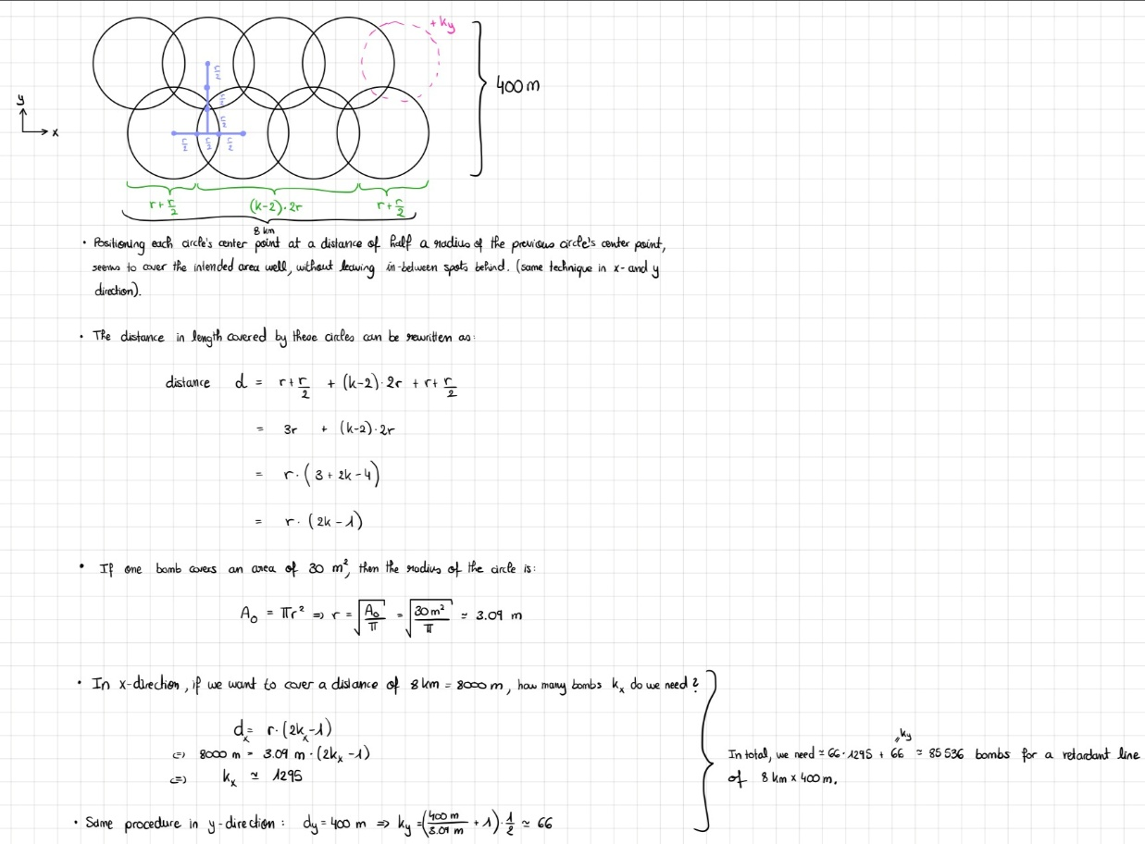
- Maximum wingspan of 15 m: The UAV should have a maximum wingspan of 15 m in order to allow it to operate from a variety of different locations.
- Maximum take-off and landing distance of 15 m: The UAV should require no more than 15 m of available distance for take-off and landing, for the same reason, allowing it to operate from relatively small and easily accessible locations. Agricultural UAVs seem to take off at a distance of 10 meters, which is why 15 meters seem reasonable to achieve.
- Accessible manufacturing and construction: The UAV should be designed using accessible manufacturing and construction technologies. This would make the UAV easier to produce and operate in different locations and would allow larger fleets to be established where required.
- Minimum endurance of 15 minutes: The UAV should have a minimum endurance of 15 minutes, based on the operational example described above (10 minute operation).
- Maximum speed of 100–130 km/h: The UAV should have a maximum speed in the range of 100–130 km/h. This would allow sufficient time for the bombs to be accurately deployed in the intended areas while also providing the control systems with enough time to process the necessary information and perform the required actions.
- Operating altitude: The UAV should be capable of operating at approximately 30–50 m above ground level (AGL) during payload deployment. A preliminary design altitude of approximately 40 m is proposed to maintain sufficient separation from the heat, smoke, and turbulence generated by the fire. The exact operating altitude should be adaptable according to terrain, vegetation height, wind conditions, fire intensity, and the presence of other firefighting aircraft.
- Range: According to the example given, a range of at least 600 m (2x244=488 meters) should be respected.

Why Choose the Dry-Powder Bomb Method Over Red Powder and Water-Based Firefighting Methods for the UAVs?
Fire Extinguishing Devices Trade-Off Tables
Argument Table
Technology Suggestions  Criteria | Red Powder/ Dry Chemical (“Fire Retardants”) | Extinguishing Grenade/ Dry Powder Bomb | Water
Area Efficiency per mass | Covers a high area per kg  4.21 m² per kg [3] | 30 kg dry powder bomb diffuses to blanket an area between 130 and 700 square meters: 4.3 to 23.3 m² per kg [4] | Poor coverage 0.01 to 0.2 m² per kg [5]
Area Efficiency per flight minute | ~350 to 400 m2  per minute [6] | ~30 m2 per minute [4] | Heavy mass limits discharge time  ~210 to 310 m2 per minute  [7]
Precision Tolerance | Not precise as broad cloud covers broad areas | Precise kinetic delivery, does not succumb so easily to wind but the trajectory upon impact must be precise to target fire correctly. can cover much area if explosion takes place a few meters before hitting, one-shot impact, highly localized area coverage, and does not depend too much on wind conditions to reach target. Better control on where it falls compared to other solutions. | Requires direct continuous hits
Total Extinguishing and risk of reignition | Rapid chemical knockdown, creates long-term barriers  Poor thermal cooling => high risk of reignition | Extremely effective on knocking canopy flames. The kinetic blast of a dry powder bomb knocks out active flames instantly by starving them of oxygen. However, it does nothing to lower the core temperature of thick wood => very high risk of reignition | Prevents reignition by thermally cooling fuel (when not evaporating too much…)
Suitability for outdoors (wind) | Wind assists the overall distribution which is good | Yes. Wind changes its trajectory the least. | Yes
Environmental impact | Ammonium polyphosphates: Toxic, especially for aquatic ecosystems (fish) and vegetation | ABC Monoammonium Phosphate: Very toxic, especially for aquatic ecosystems (fish), vegetation and terrestrial wildlife | No
Cost | Moderate | High | Low
Availability/ Accessibility | Restricted (Requires advanced manufacturing and mixing bases) | Highly Accessible (Stored easily in local fire stations) | Theoretically infinite and immediate (but depends on location and up to water availability)

Weighing factors legend:
Importance of criteria: 1-7
Marks: 1-3

Score Table
Technology Suggestions  Criteria | Red Powder/ Dry Chemical (“Fire Retardants”) | Extinguishing Grenade/ Dry Powder Bomb | Water
Area Efficiency per mass (7) | 2 | 3 | 1
Area Efficiency per flight minute (6) | 3 | 1 | 2
Precision  Tolerance (3) | 1 | 3 | 1
Total Extinguishing and risk of reignition (3) | 1 | 2 | 3
Suitability for outdoors (Type A Fires) (5) | 3 | 3 | 3
Environmental impact (2) | 1 | 1 | 3
Cost (1) | 2 | 1 | 3
Availability/ Accessibility (2) | 1 | 2 | 3
TOTAL: | 59 | 64 | 61

To be noted: Water deployment remains indispensable at some stage of suppression because it absorbs residual thermal energy to prevent reignition. While these tactics complement one another, payload-limited UAVs should prioritize precision chemical retardants or dry-powder bomb strategies rather than bulk water delivery, which requires a much heavier cargo capacity. Moreover, dry-powder bombs appear to be particularly suitable in conditions of high wind, as their compact, rounded shape would be less likely to be displaced unpredictably by the wind than loose red powder. Additionally, the altitude at which the bomb disperses its contents could be controlled.

Red Powder Examples:
- https://www.perimeter-solutions.com/product/phos-chek-259-fx-2/
- https://xpyro.fi/ (more eco-friendly)

Dry Powder Bomb Examples:
- https://jinghongdrone.com/fire-extinguishing-bomb-deployment-device (bombs (23 kg each) with 20 kg extinguishing agent per unit, providing coverage of ≥ 50 m² and safe wireless deployment)
- https://www.youtube.com/shorts/bTtY0pKd4pU
- How it works: https://salgrom.fi/en/how-does-impulse-dry-powder-fire-suppression-work/

References

[1] https://forest-fire.emergency.copernicus.eu/apps/effis.statistics/estimates
[2] https://civil-protection-humanitarian-aid.ec.europa.eu/news-stories/stories/helping-greece-tackle-largest-wildfires-century-europe_en
[3] https://www.google.com/url?sa=i&source=web&rct=j&url=/goto?url%3DCAESlgEB6zswFaW6jig_nAzX5a_wuSaun9QoBNS2FJNdq4DhdCqCsjF2YeGIPwS30PeL7lgwNpzXbBMquxrUHsJ1aPgX7LqV9FkTJmAQVq-u6UTnTqVSLL_fguXw6LhQijW65jju9XBnDlppdOvEpJsm8bgwboF16mUq8fn1g9E8_LpZjDJF-7ScNL422HSru0BzK4vkxFvbdXI&ved=2ahUKEwiqssbbkIOXAxVdHhAIHW0QHMQQqYcPegYIAAgnEAI&opi=89978449&cd&psig=AOvVaw0KnjIk9wtdBAUFHfSz9hOf&ust=1790198896298000
[4]
https://jinghongdrone.com/uav-for-fire-fighting-key-technologies-and-features-explained
[5]
https://wmpllc.org/ojs/index.php/jem/article/view/2689
[6]
https://www.fs.usda.gov/t-d/pubs/pdfpubs/pdf00572851/pdf00572851_72dpi.pdf
[7]
https://en.wikipedia.org/wiki/Canadair_CL-415

